HINTS-
Use man <command> on terminal to learn description

Level 0

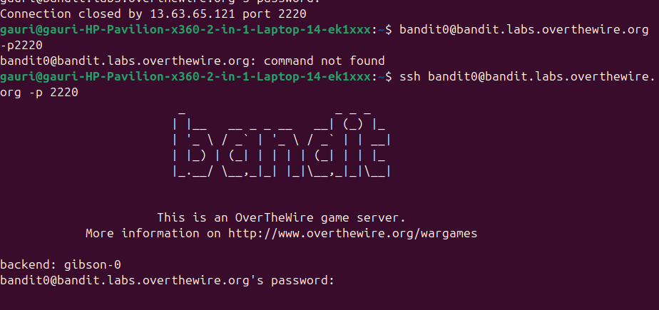

command is: ssh <username>@<website_name> -p 2220
then password is asked: bandit0
In some time it will get closed automatically and we have to login again.
If you mess up at any point (like forget to add the username bandit0, and just used ssh bandit.lab.overthewire.org -p2220) then type: exit

Level 1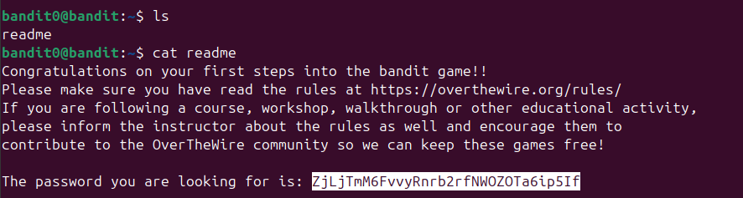

command is: ls
command is: cat readme
we get password: ZjLjTmM6FvvyRnrb2rfNWOZOTa6ip5If

ls is used to list directory content. More info here: https://manpages.ubuntu.com/manpages/noble/man1/ls.1.html
More info here: https://www.geeksforgeeks.org/linux-unix/ls-command-in-linux/
ls -1 is used to list the detailed information about the files and directories in the current folder.
cat command is used to view files 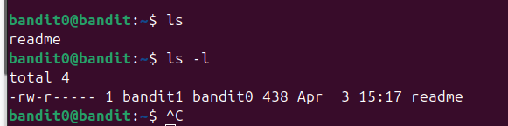

(https://www.cyberciti.biz/faq/linux-unix-appleosx-bsd-cat-command-examples/)

In the Linux command line, Ctrl+C sends a SIGINT (Signal Interrupt) to the currently running foreground process, instructing it to stop and exit immediately. This acts as a "cancel" or "stop" button, interrupting operations like infinite loops or long-running commands (e.g., ping) and returning control to the shell prompt. Unlike in graphical user interfaces where Ctrl+C is used for copying text, to copy text from a Linux terminal, users must use Ctrl+Shift+C instead

level 2:
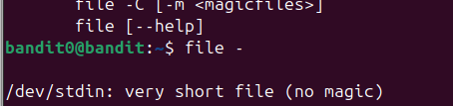
filename is dashed (sources: https://medium.com/@.Qubit/how-to-create-open-find-remove-dashed-filename-in-linux-27ee297d1740)
ls doesn't mention '-' as any file
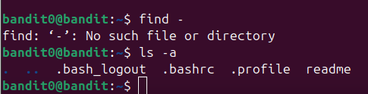
find - also doesn't help
ls-a to view hidden files... doesn't really show - as a file
The usual syntax from cat will not work as cat would consider (-) as an STDIN and wait for user INPUT on the screen. The proper way to view content of dashed filename would be again to prefix the path of the file
The proper way to view content of dashed filename would be again to prefix the path of the file

file <filename> is used to view what the type of a file. It identifies file types by examining their content rather than their file extensions, making it an indispensable tool for users who work with various file formats.

FROM START
bandit0@----

ZjLjTmM6FvvyRnrb2rfNWOZOTa6ip5If

Then we have to type exit and again ssh -p 2220 bandit1@bandit.labs.overthewire.org

bandit1@-----
Command is
ls
cat ./-
Password is
263JGJPfgU6LtdEvgfWU1XP5yac29mFx

bandit2@-----
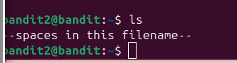

After multiple tries, this is correct:
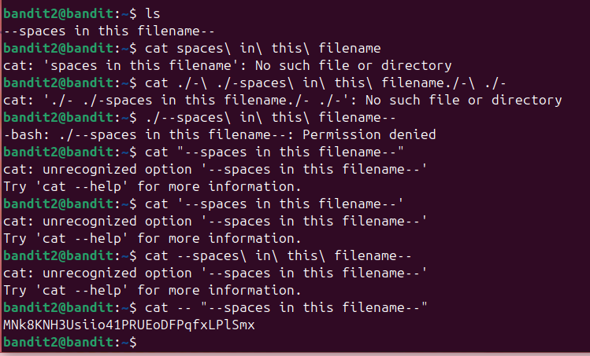
MNk8KNH3Usiio41PRUEoDFPqfxLPlSmx

bandit3@---

ls
cd inhere
ls -a
cat ./...Hiding-From-You

2WmrDFRmJIq3IPxneAaMGhap0pFhF3NJ

Bandit 04
New command: file <name of file>* to know file type 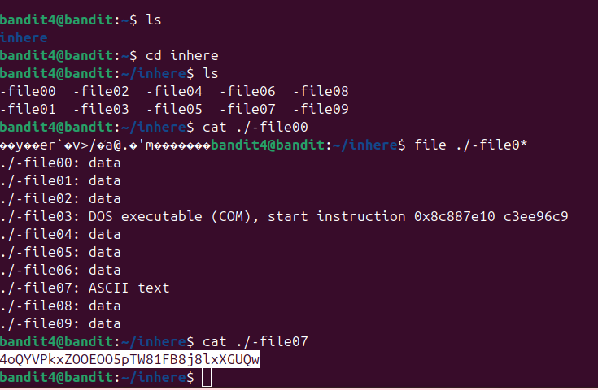
4oQYVPkxZOOEOO5pTW81FB8j8lxXGUQw

Bandit 5@....
Ok this level brought me sweats

New command learned- find
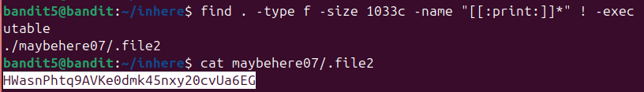

HWasnPhtq9AVKe0dmk45nxy20cvUa6EG

Bandit 6 was sweaty too cuz I forgot / after command find
Password ka path is:
/var/lib/dpkg/info/bandit7.password
Password is
morbNTDkSW6jIlUc0ymOdMaLnOlFVAaj

bandit7@-----

The password for the next level is stored in the file data.txt next to the word millionth

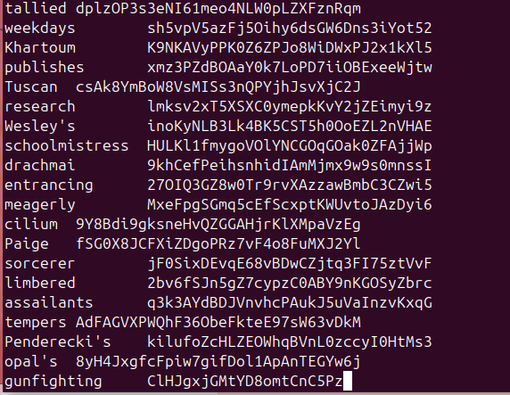
(i just wrote cat readme.txt and it all bombarded on my terminal)

Pass:
dfwvzFQi4mU0wfNbFOe9RoWskMLg7eEc

bandit8@----
ls
data.txt
Now to find unique wala, we do sorting and then uniq
Password
4CKMh1JI91bUIZZPXDqGanal4xvAg0JM
bandit9@----
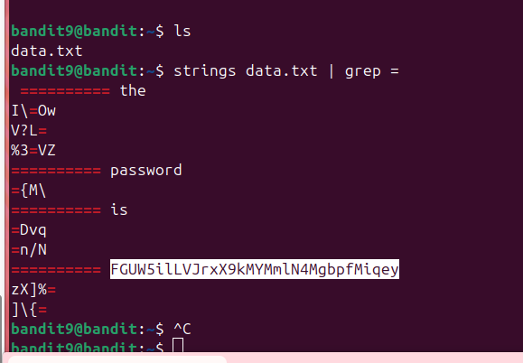
FGUW5ilLVJrxX9kMYMmlN4MgbpfMiqey

Bandit10@---

The password for the next level is stored in the file data.txt, which contains base64 encoded data
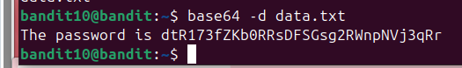
dtR173fZKb0RRsDFSGsg2RWnpNVj3qRr

bandit11@----

The password for the next level is stored in the file data.txt, where all lowercase (a-z) and uppercase (A-Z) letters have been rotated by 13 positions

Command:
tr to translate characters
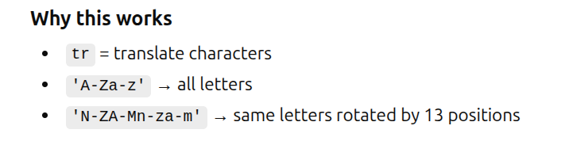

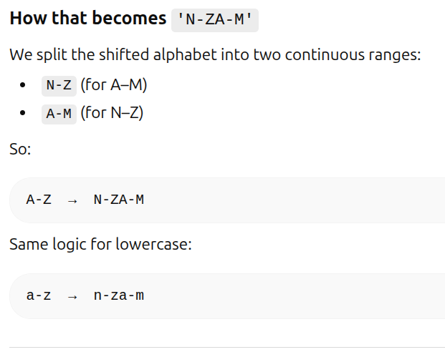

7x16WNeHIi5YkIhWsfFIqoognUTyj9Q4

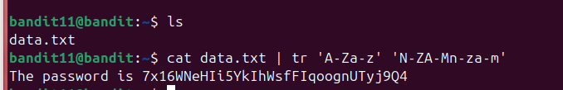

bandit12@-----

